SIMATS ENGINEERING
ASSESSMENT TOOL 2

COURSE NAME:Database Management Systems
COURSE CODE:CSA05

COURSE OUTCOME COVERED
CO2: Apply the relational model, relational algebra, SQL query structures, and views to solve database querying and data manipulation problems. (BL3, BL6)
Activity Tool : Scenario-Based Task (Medium)
Assessment Tool Weightage: 20%

QUESTIONS
Q.No | Question | Bloom's Level
1 | A university stores student and course data in a single table. Analyze the structure and identify normalization issues, then redesign it up to 3NF | . BL4 – Analyze
2 | A company database contains employee and department details. Design appropriate SQL queries to retrieve employees working in multiple departments and justify your approach | . BL6 – Create
3 | Given a relation with multiple functional dependencies, determine the candidate keys and check whether the relation satisfies BCNF. If not, decompose it. | BL5 – Evaluate
4 | A banking system requires secure data access. Design views and constraints to ensure data security and integrity for different types of users. | BL6 – Create
5 | A sales database contains redundant data leading to anomalies. Analyze the schema and apply normalization up to 3NF or BCNF to eliminate redundancy. | BL4 – Analyze
6 | Given a dataset of customers and orders, write SQL queries using joins and subqueries to retrieve meaningful information such as frequent customers. | BL3 – Apply
7 | A relation contains multi-valued dependencies. Analyze the structure and decompose it into 4NF, explaining the reasoning. | BL4 – Analyze
8 | A database designer used improper constraints, leading to inconsistent data. Evaluate the schema and suggest appropriate integrity constraints. | BL5 – Evaluate
9 | For a given relational schema, analyze the presence of join dependencies and decompose it into 5NF to remove redundancy. | BL6 – Create
10 | A system uses inefficient SQL queries for data retrieval. Analyze the queries and optimize them using joins, indexing concepts, or query restructuring. | BL5 – Evaluate

Code of Conduct:
I Tharun Kumar-192571017 certify that this submission is my original work and that I have adhered to the guidelines specified for this assessment.
I understand that any violation of academic integrity rules will result in disciplinary action.
Signature of the student:


RUBRICS FOR CALCULATION:

Criteria | Level 4 (Exemplary) | Level 3 (Proficient) | Level 2 (Developing) | Level 1 (Beginning)
Understanding of Scenario | Demonstrates clear and complete understanding of the scenario and context | Shows good understanding with minor gaps | Partial understanding; misses key aspects | Misinterprets or fails to understand the scenario
Identification of Key Issues | Accurately identifies all relevant issues and factors involved | Identifies most key issues with minor omissions | Identifies limited issues; some irrelevant points | Unable to identify key issues
Application of Concepts | Applies appropriate concepts effectively to address the scenario | Applies concepts with minor errors | Limited or partially correct application | Unable to apply relevant concepts
Decision Making | Makes well-reasoned, logical decisions with strong rationale | Makes reasonable decisions with some justification | Makes weak decisions with limited justification | No clear decisions made or rationale provided
Clarity of Response | Response is clear, structured, and logically presented | Generally clear with minor issues | Somewhat unclear or poorly structured | Disorganized and difficult to understand

Q1. A university stores student and course data in a single table. Analyze the structure and identify normalization issues, then redesign it up to 3NF.

Scenario-Based Explanation
A university stores student, course, and faculty information in a single table. Since a student can enroll in multiple courses and one faculty member can teach multiple courses, the same information is repeated in several rows. This creates data redundancy, update anomalies, insert anomalies, and delete anomalies. To improve the database design, the relation is normalized into 1NF, 2NF, and finally 3NF, where student, course, faculty, and enrollment information are stored in separate tables.

Database Creation:

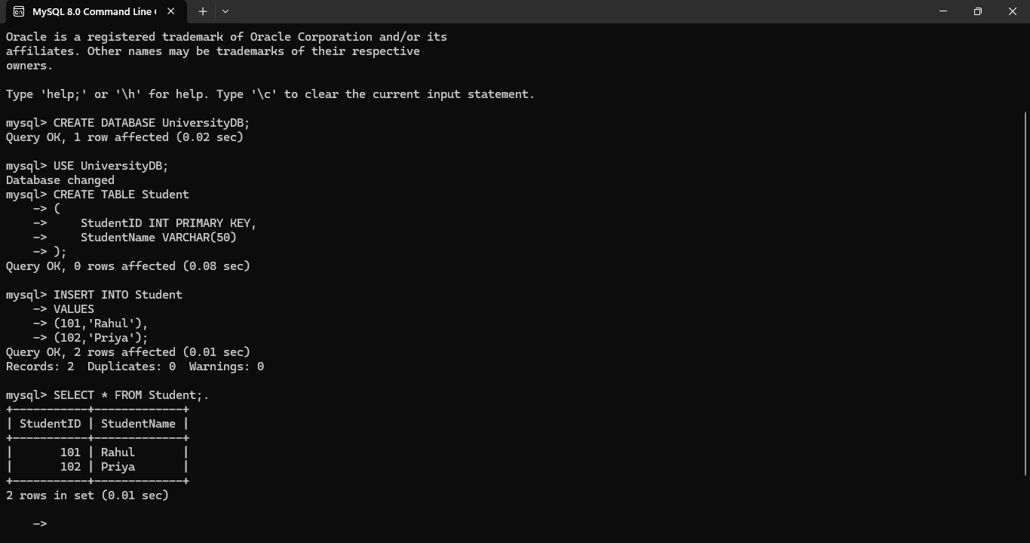
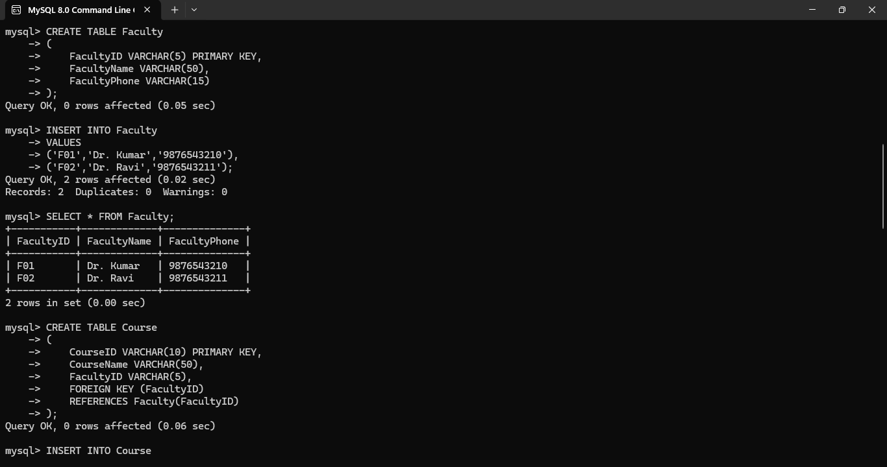
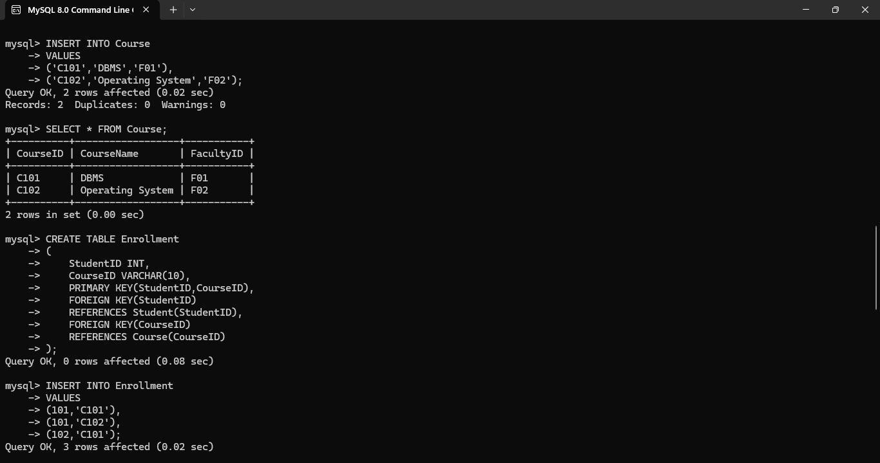
Output: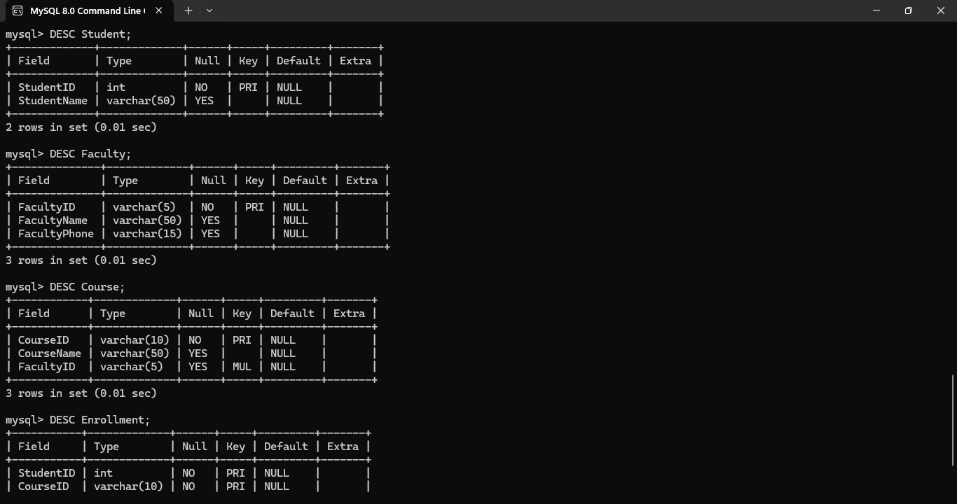

Conclusion
The university database was successfully normalized up to Third Normal Form (3NF) by separating student, faculty, course, and enrollment information into individual tables. This design removes redundancy, eliminates update, insert, and delete anomalies, and improves data integrity, consistency, and maintainability.

Q2. A company database contains employee and department details. Design appropriate SQL queries to retrieve employees working in multiple departments and justify your approach.

Scenario-Based Explanation
A company maintains employee and department information in its database. Some employees work in more than one department because they are assigned to multiple projects. The company wants to identify such employees for resource management and performance evaluation. An Employee-Department mapping table is created to store department assignments. SQL joins and aggregation functions are used to retrieve employees who belong to multiple departments.
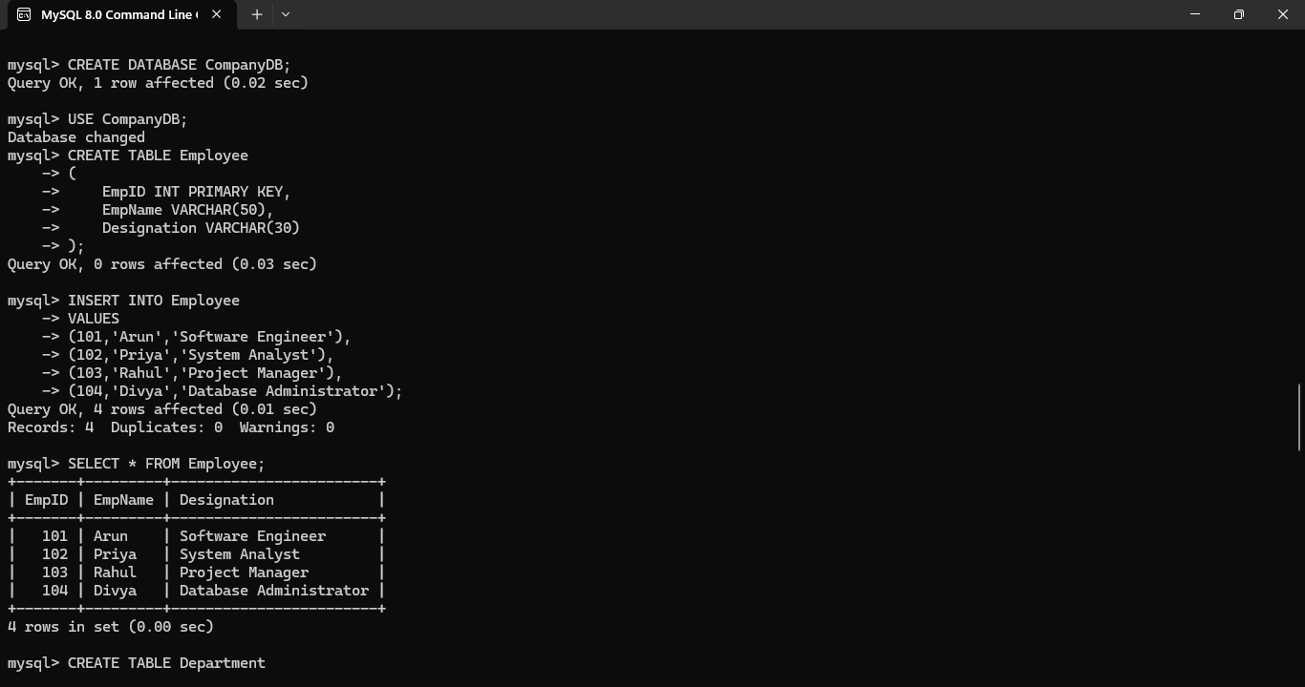
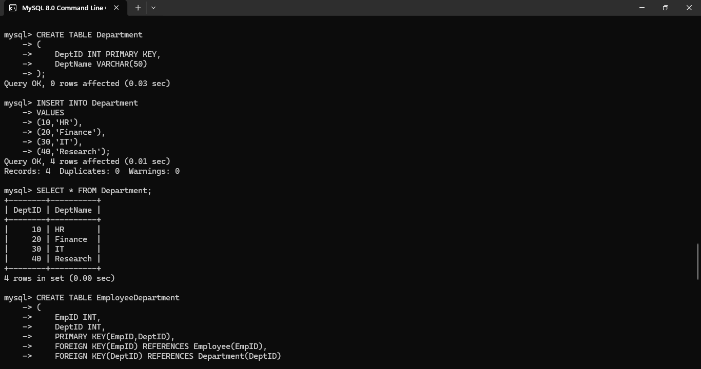

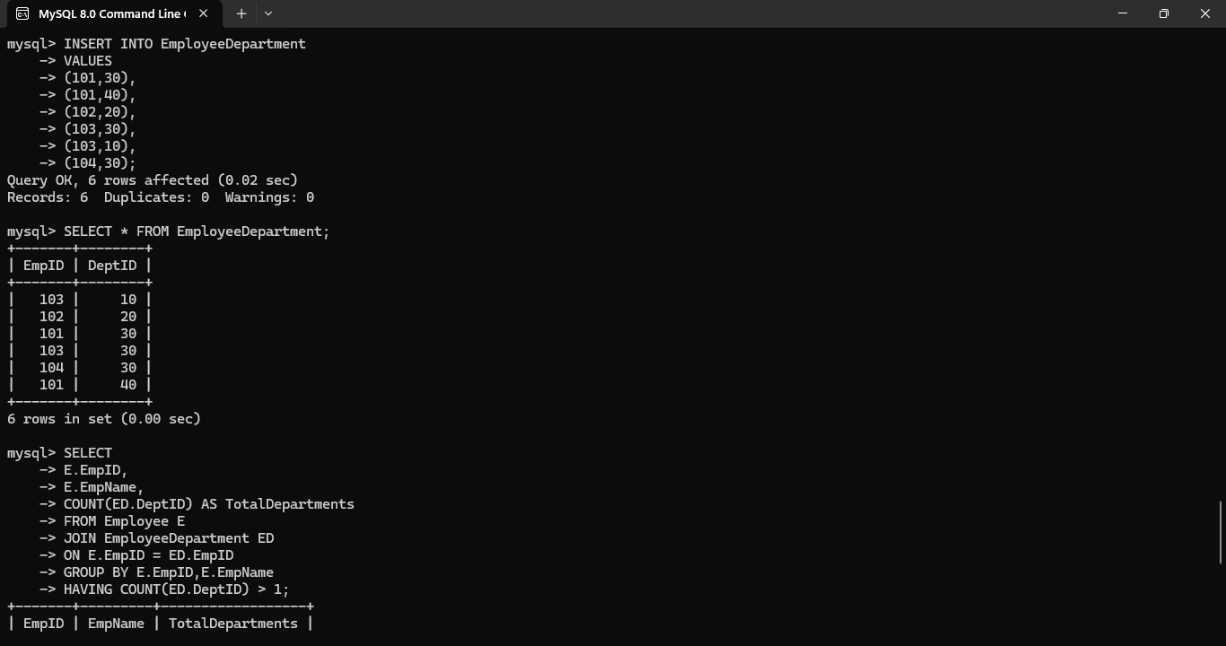
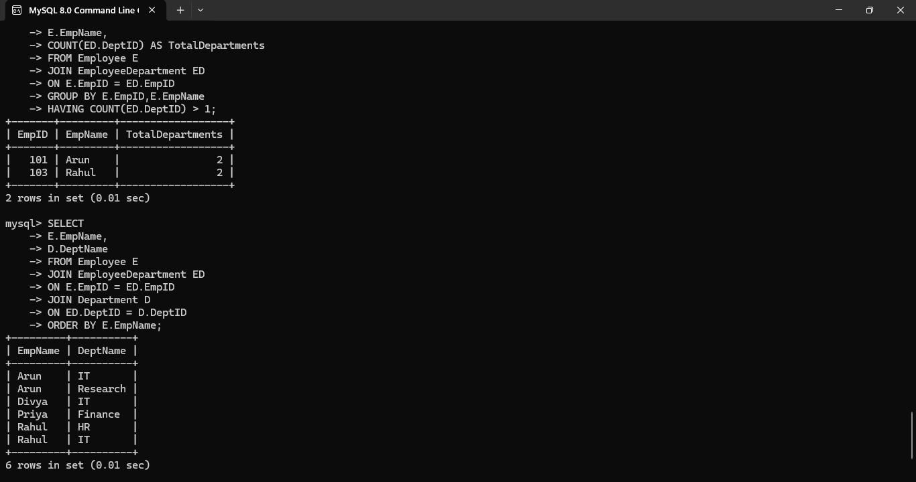

Justification of the Approach
- JOIN combines data from the Employee, EmployeeDepartment, and Department tables.
- GROUP BY groups records based on each employee.
- COUNT() calculates the number of departments assigned to each employee.
- HAVING COUNT(DeptID) > 1 filters only those employees working in multiple departments.
- This approach is efficient because it avoids duplicate records and accurately identifies employees with multiple department assignments.

Conclusion
The SQL queries successfully retrieved employees working in multiple departments by using JOIN, GROUP BY, and HAVING clauses. The database design with separate Employee, Department, and EmployeeDepartment tables reduces redundancy and supports efficient retrieval of employee assignment information.
Q3. Given a relation with multiple functional dependencies, determine the candidate keys and check whether the relation satisfies BCNF. If not, decompose it.

Scenario-Based Explanation
A company stores employee information in a single relation. The relation contains multiple functional dependencies, which may introduce redundancy and update anomalies if the determinant is not a candidate key. The database designer must identify the candidate key, check whether the relation satisfies BCNF, and decompose the relation into smaller tables if a BCNF violation is found.

Candidate Key
BookID+

= {BookID}

BookID → BookTitle, PublisherID

= {BookID, BookTitle, PublisherID}

PublisherID → PublisherName, PublisherCity

= {BookID, BookTitle, PublisherID, PublisherName, PublisherCity}
Since all attributes are obtained,
Candidate Key = BookID

BCNF Check
FD1
BookID → BookTitle, PublisherID
BCNF Satisfied (BookID is the candidate key)
FD2
PublisherID → PublisherName, PublisherCity
BCNF Violated (PublisherID is not the candidate key)
Hence, the relation is not in BCNF.

BCNF Decomposition:
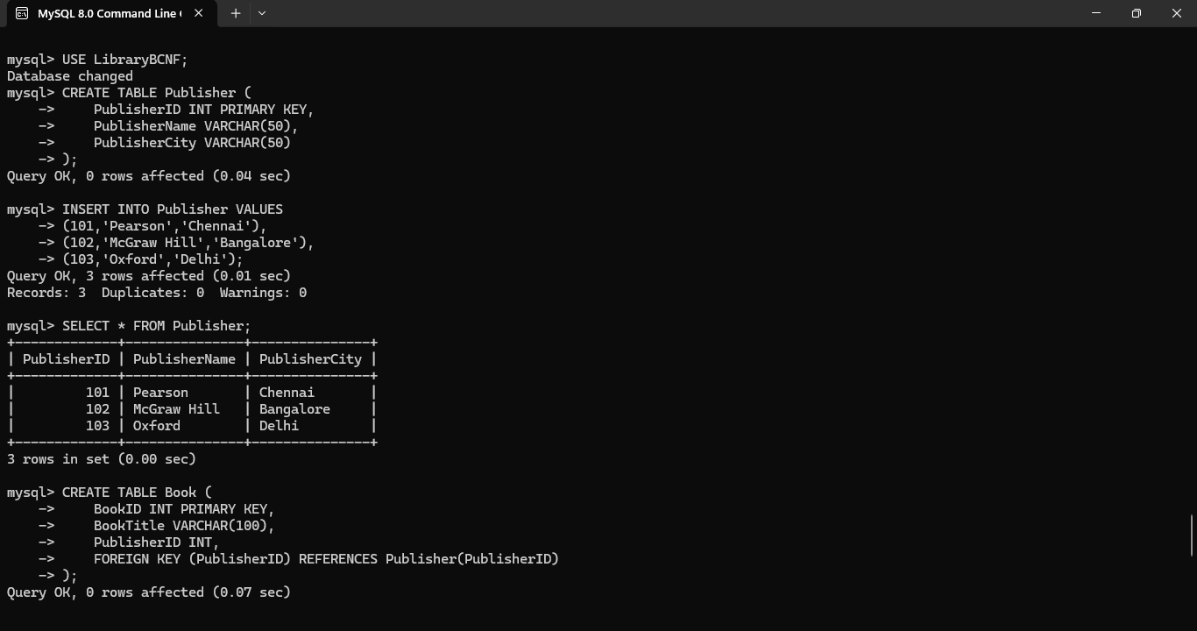
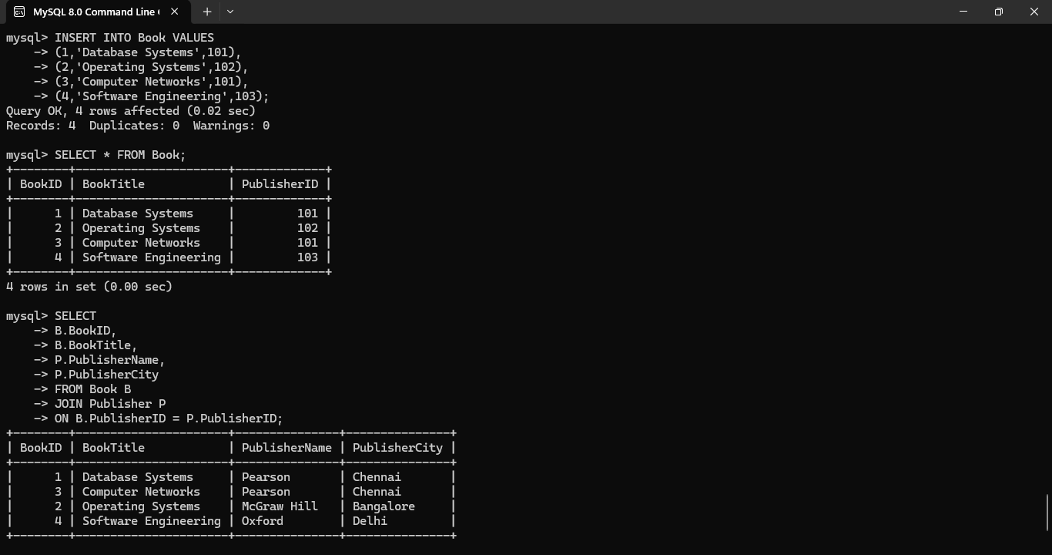

Conclusion
The candidate key was identified as BookID. Since the dependency PublisherID PublisherName, PublisherCity violated BCNF, the relation was decomposed into Book and Publisher tables. This decomposition removes redundancy, improves data integrity, and satisfies Boyce-Codd Normal Form (BCNF).
Q4. A banking system requires secure data access. Design views and constraints to ensure data security and integrity for different types of users.

Scenario-Based Explanation
A bank maintains customer account details such as account number, customer name, account type, balance, and branch. Different users require different levels of access. For example, a Bank Manager can view all customer details, whereas a Customer should only view basic account information. To ensure security and maintain data integrity, SQL views and constraints
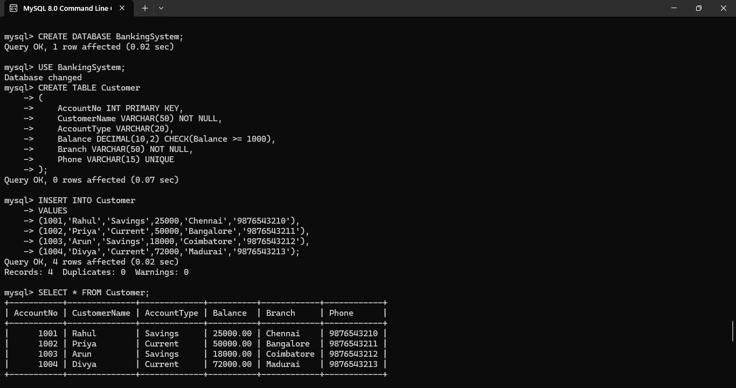

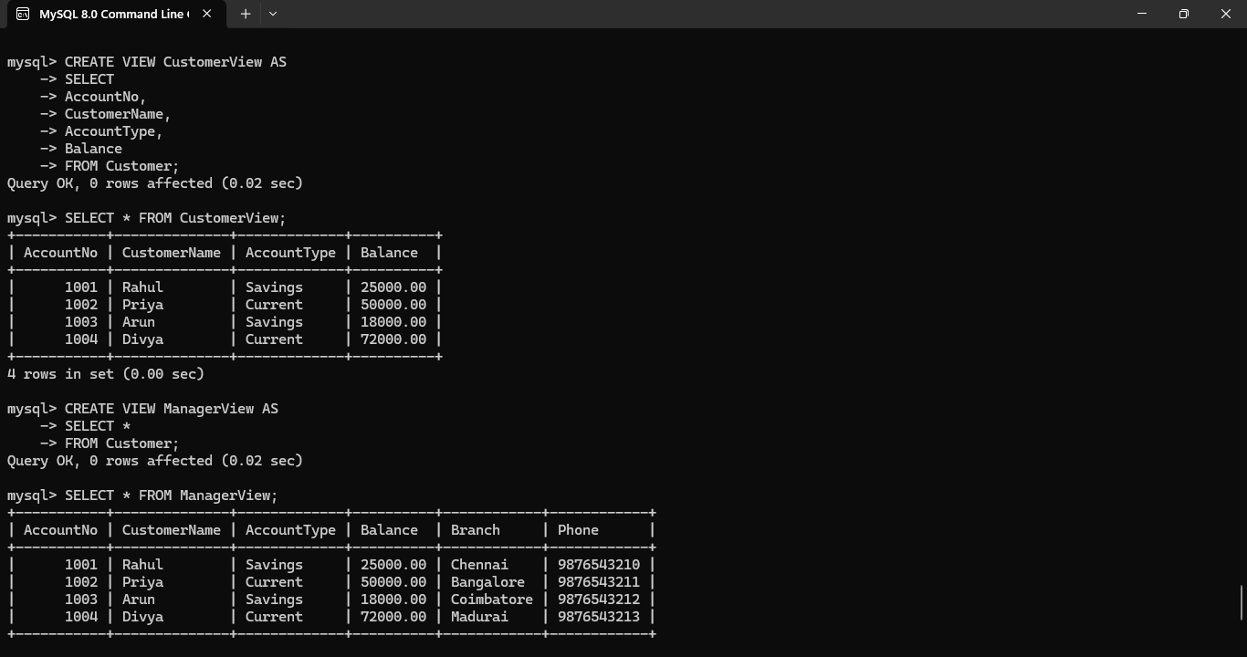
Justification
- Views restrict data access based on user roles.
- CustomerView displays only essential account information.
- ManagerView provides complete customer details for administrative purposes.
- Constraints prevent invalid or duplicate data from being stored in the database, thereby maintaining integrity and consistency.

Conclusion
The banking database was successfully designed with views and integrity constraints to ensure secure data access and reliable data storage. The use of CustomerView and ManagerView provides role-based access control, while constraints such as PRIMARY KEY, NOT NULL, UNIQUE, and CHECK maintain data integrity and prevent invalid entries.

Q5. A sales database contains redundant data leading to anomalies. Analyze the schema and apply normalization up to 3NF or BCNF to eliminate redundancy.

Scenario-Based Explanation
A sales company stores customer, product, and order details in a single table. Since a customer can place multiple orders and multiple customers can purchase the same product, customer and product information is repeated many times. This causes data redundancy, update anomalies, insert anomalies, and delete anomalies. To improve the database structure, the data is normalized into separate tables for Customers, Products, Orders, and OrderDetails.
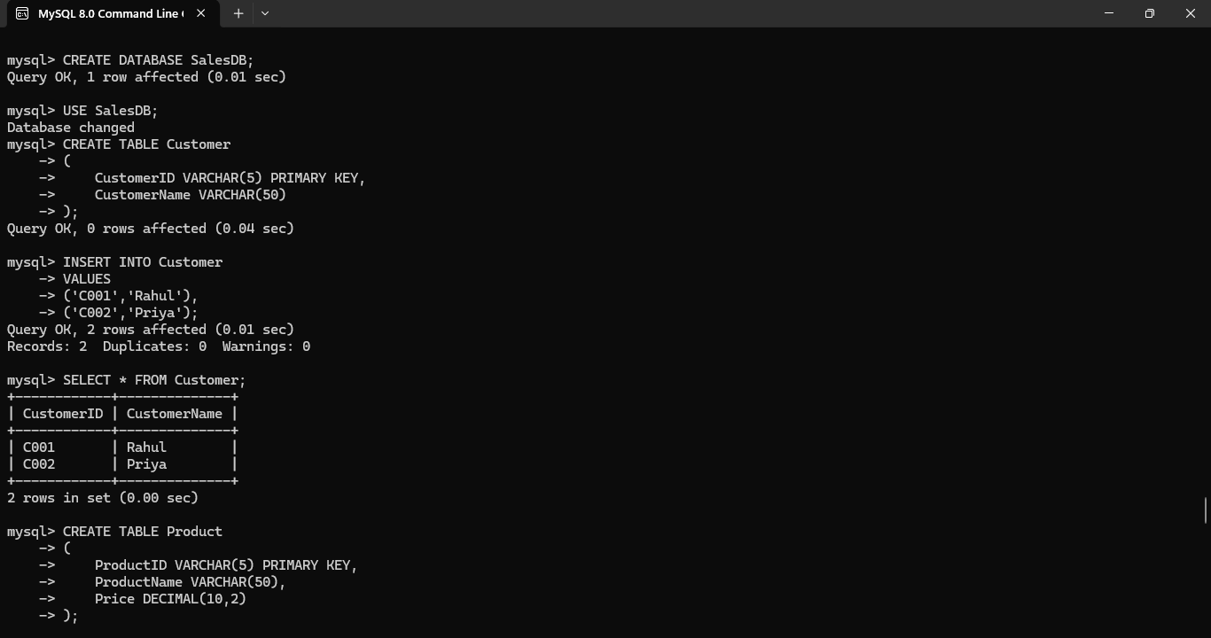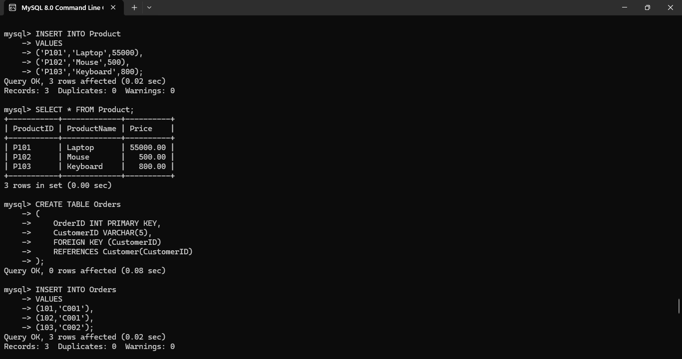
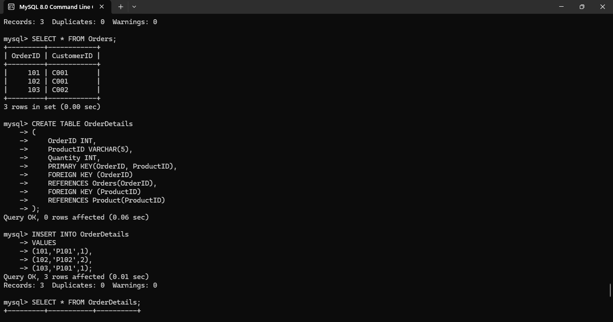
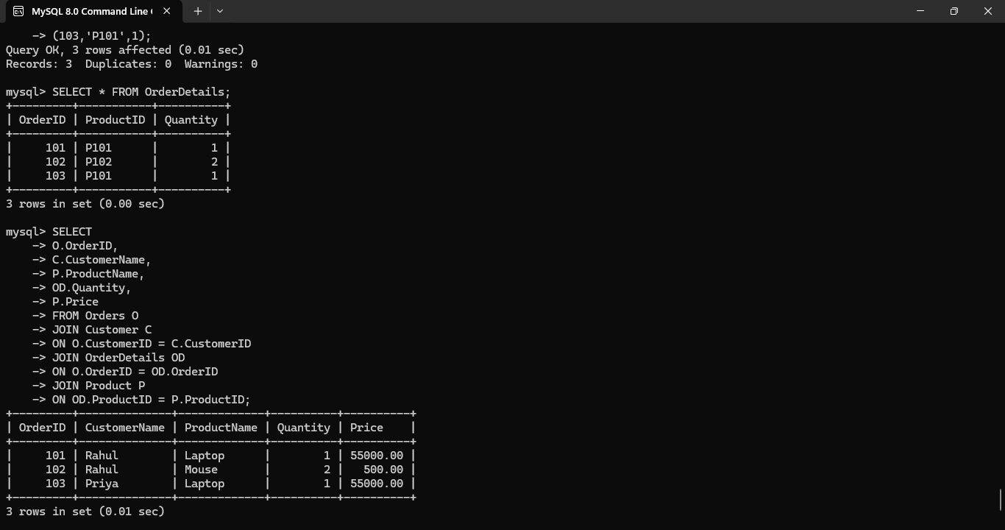

Justification
- Customer information is stored only once in the Customer table.
- Product information is stored only once in the Product table.
- Orders and products are linked using the OrderDetails table.
- The normalized design removes redundancy and prevents update, insertion, and deletion anomalies.
Conclusion
The sales database was successfully normalized into Third Normal Form (3NF) by separating customer, product, order, and order details into individual tables. This design eliminates redundancy, improves data consistency, reduces storage requirements, and prevents update, insertion, and deletion anomalies.

Q6. Given a dataset of customers and orders, write SQL queries using joins and subqueries to retrieve meaningful information such as frequent customers.

Scenario-Based Explanation
An online shopping company maintains separate tables for Customers and Orders. The management wants to identify frequent customers who place multiple orders and generate reports showing customer order details. To achieve this, SQL JOIN operations combine data from multiple tables, while subqueries identify customers who have placed more than one order.
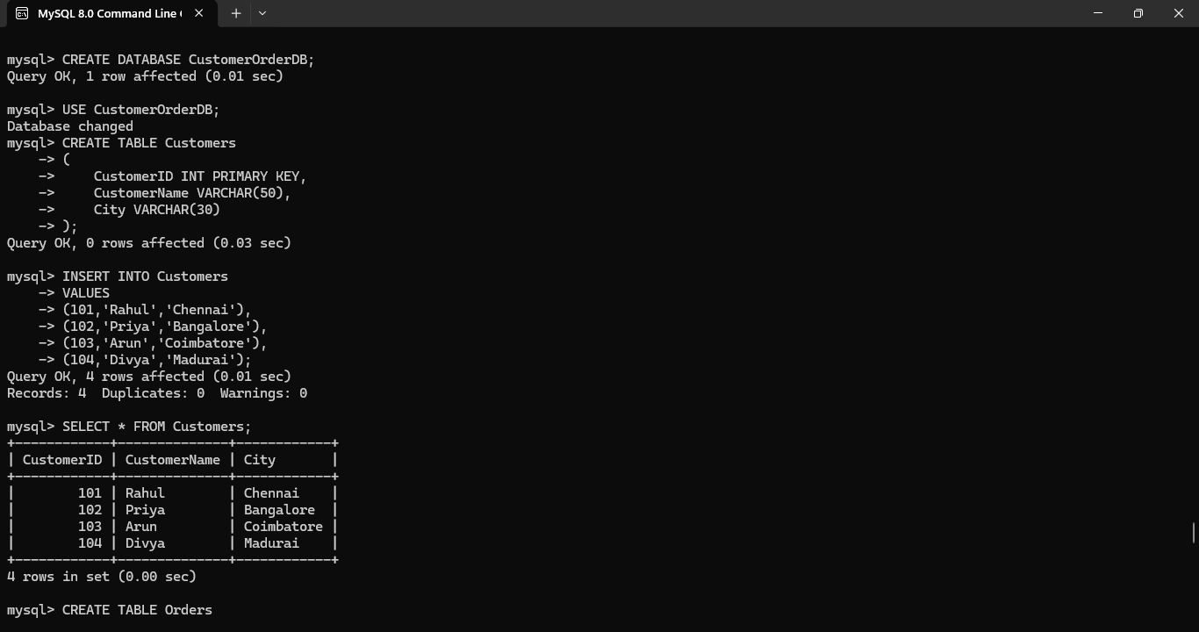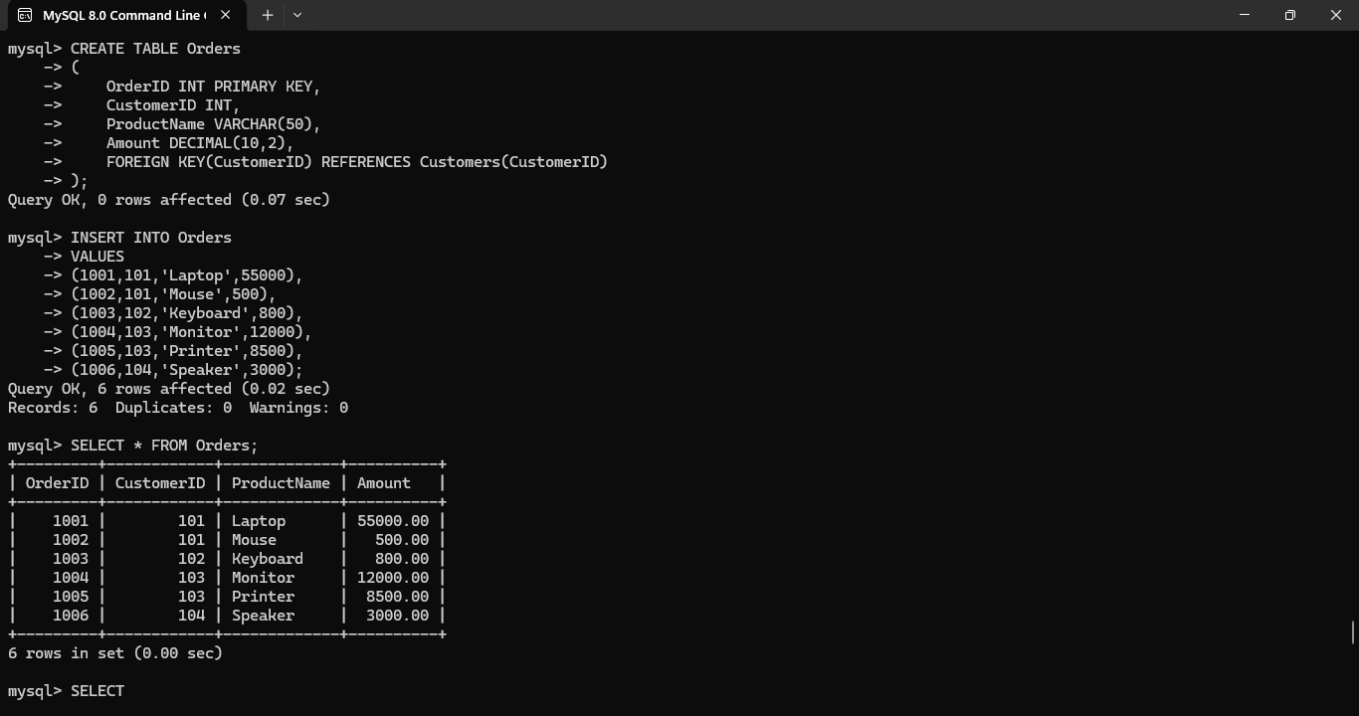
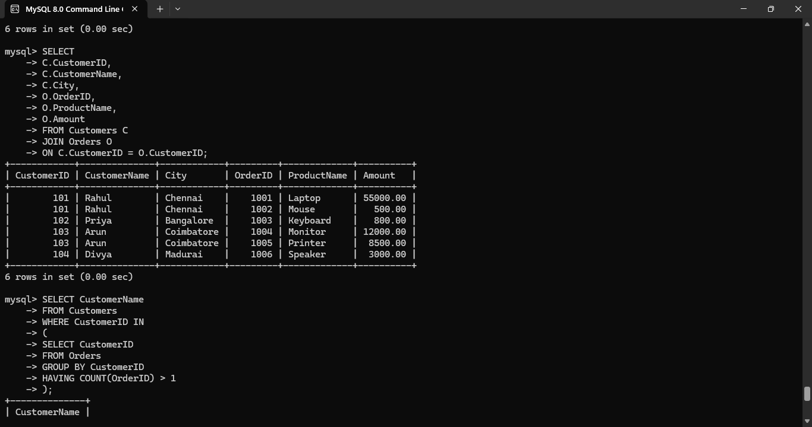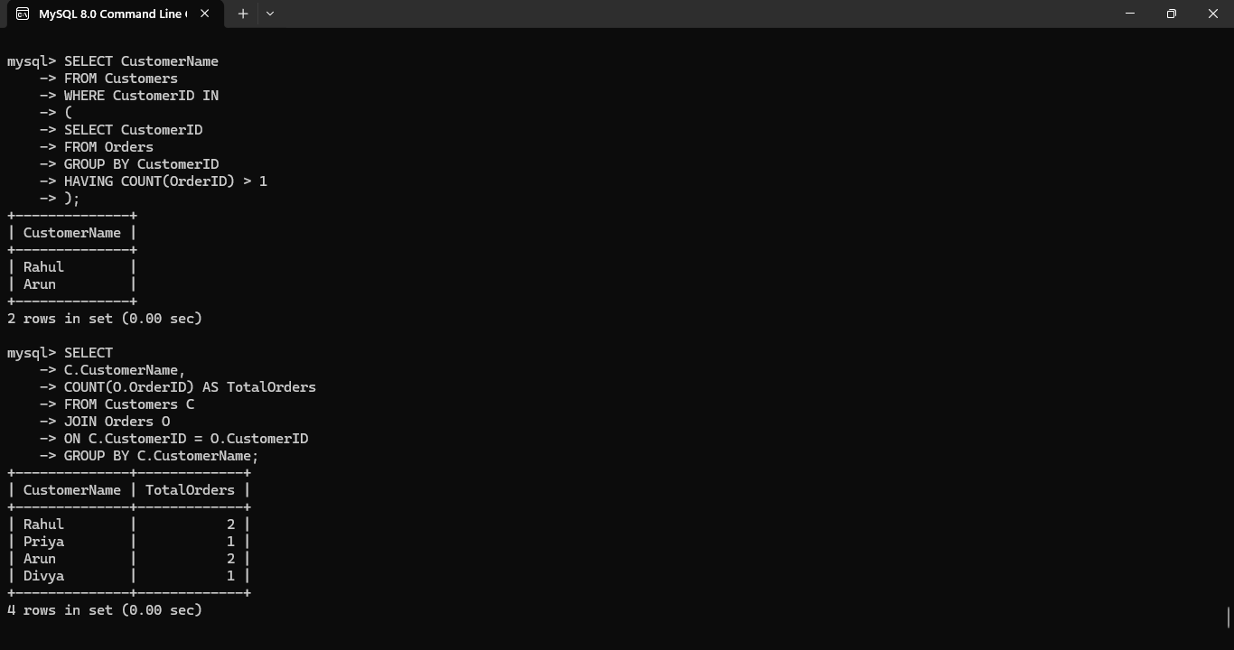

Justification
- JOIN combines customer and order information stored in separate tables.
- The subquery identifies customers who have placed more than one order.
- GROUP BY and COUNT() calculate the number of orders placed by each customer.
- This approach helps businesses identify frequent customers for loyalty programs, discounts, and marketing campaigns.

Conclusion
The customer and orders database was successfully analyzed using JOINs and subqueries. The SQL queries retrieved customer order details and identified frequent customers based on multiple purchases. This approach enables efficient reporting and supports better business decision-making.
Q7. A relation contains multi-valued dependencies. Analyze the structure and decompose it into 4NF, explaining the reasoning.

Scenario-Based Explanation
A training institute stores information about employees, their skills, and certifications in a single table. An employee can possess multiple skills and multiple certifications, and these are independent of each other. This creates multi-valued dependencies, resulting in redundant data and unnecessary duplication. To remove this redundancy, the relation is decomposed into Fourth Normal Form (4NF).
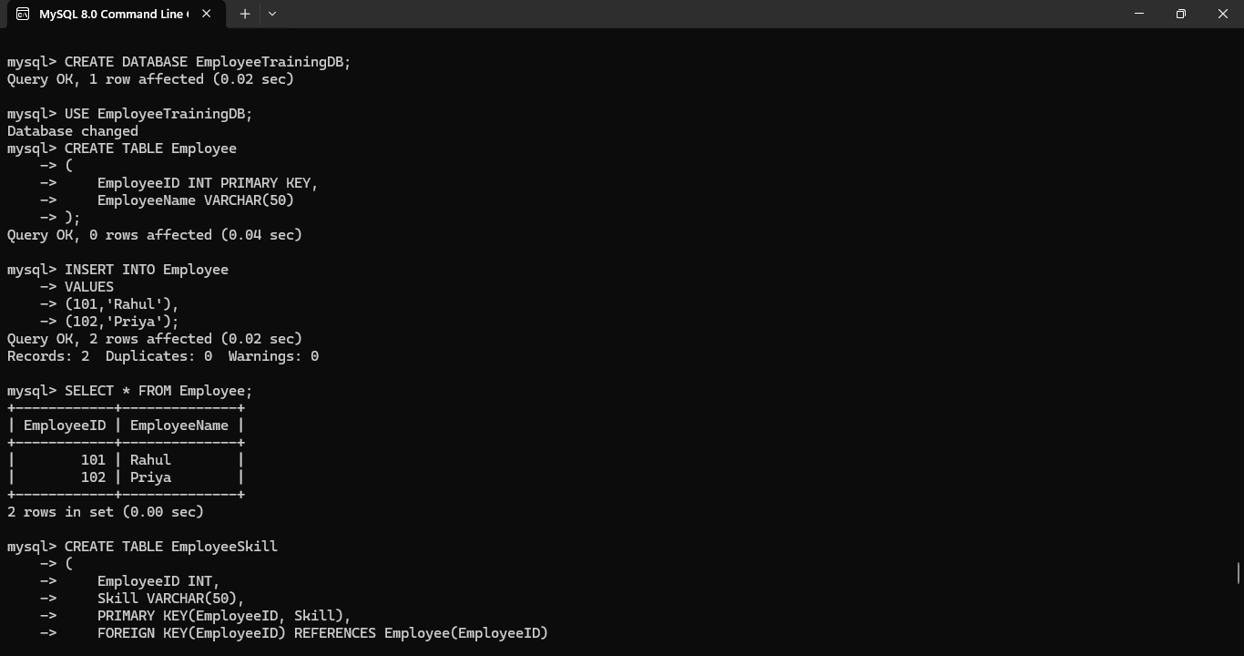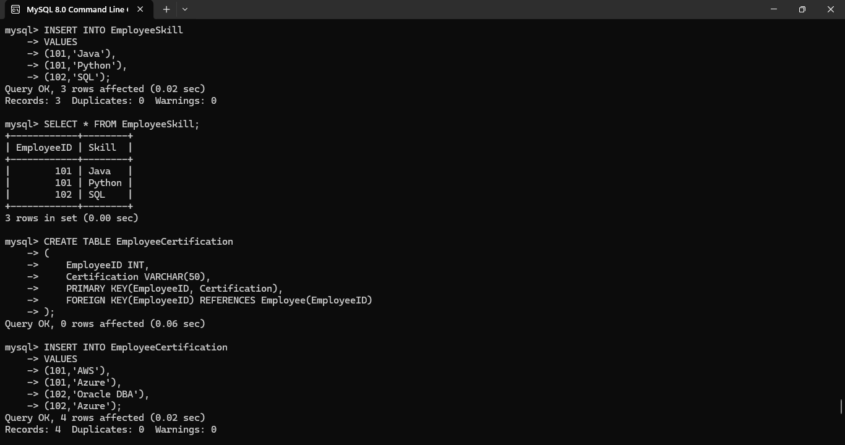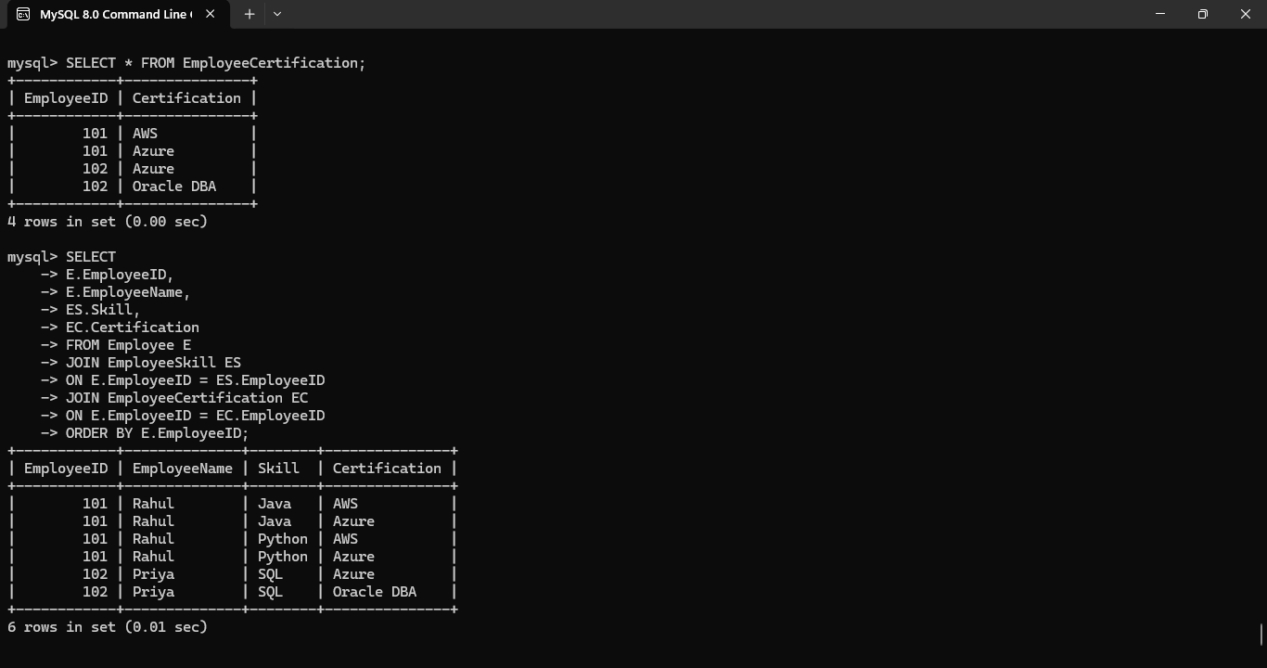

Q8. A database designer used improper constraints, leading to inconsistent data. Evaluate the schema and suggest appropriate integrity constraints.

Scenario-Based Explanation
A company maintains employee records in its database. Due to the absence of proper integrity constraints, duplicate employee IDs, null employee names, negative salaries, duplicate email addresses, and invalid department references are allowed. These issues lead to inconsistent and unreliable data. To solve these problems, appropriate constraints such as PRIMARY KEY, FOREIGN KEY, NOT NULL, UNIQUE, and CHECK are applied.
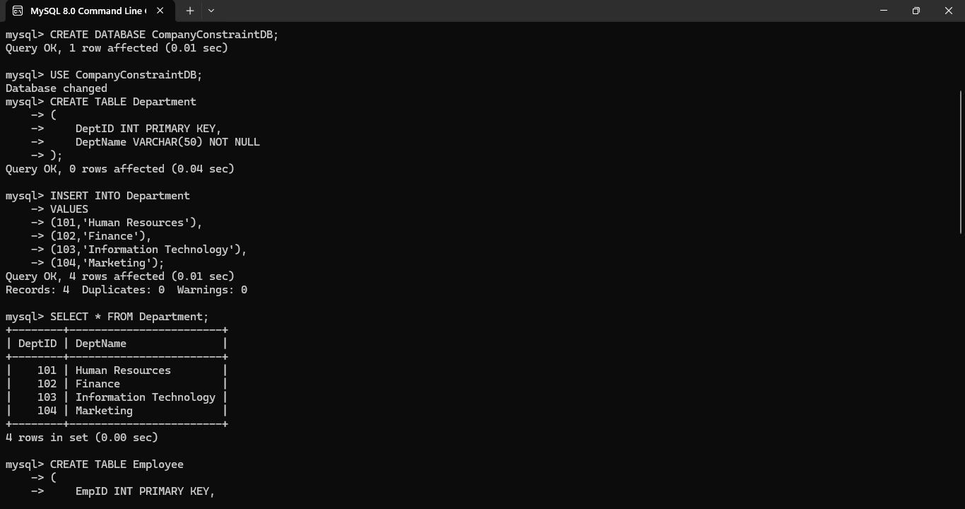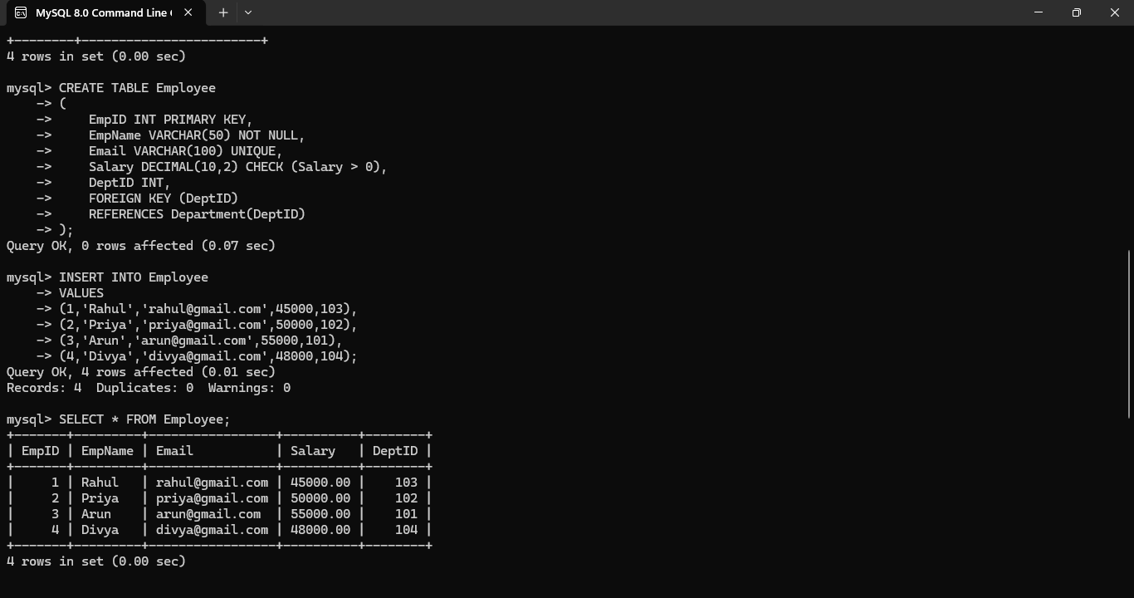
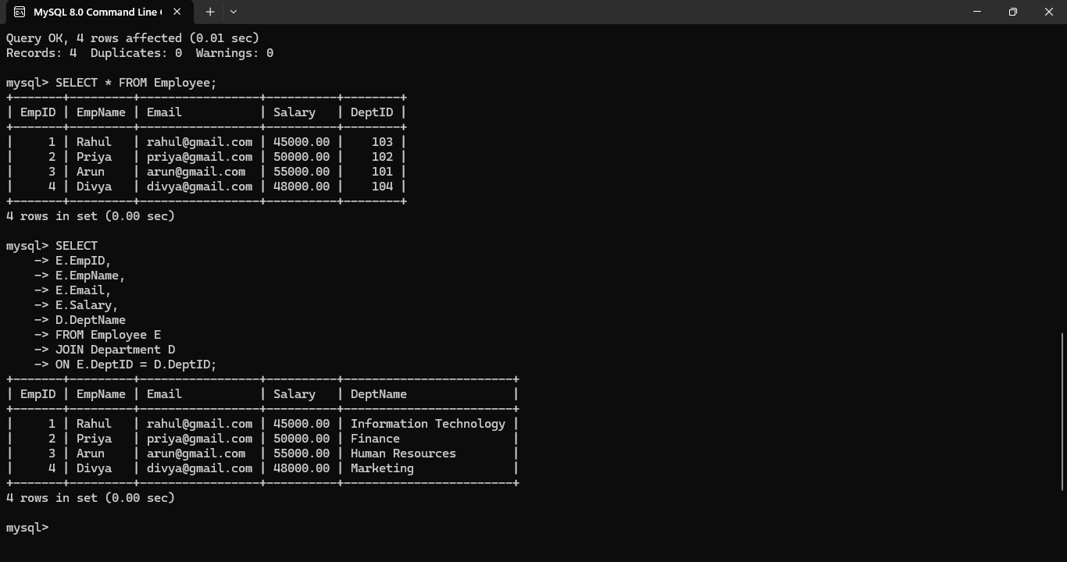

Justification
- PRIMARY KEY prevents duplicate employee IDs.
- FOREIGN KEY maintains referential integrity between Employee and Department tables.
- NOT NULL ensures mandatory employee information is provided.
- UNIQUE prevents duplicate email addresses.
- CHECK ensures only valid salary values are stored.

Conclusion
The database schema was evaluated, and appropriate integrity constraints were successfully applied. These constraints prevent duplicate, invalid, and inconsistent data while maintaining data accuracy, reliability, and referential integrity. The improved schema supports efficient and secure database operations.

Q9. For a given relational schema, analyze the presence of join dependencies and decompose it into 5NF to remove redundancy.

Scenario-Based Explanation
A manufacturing company maintains information about Suppliers, Products, and Projects in a single table. A supplier can supply multiple products for different projects. Storing all three entities together creates redundant combinations and join dependencies. To eliminate redundancy and maintain data consistency, the relation is decomposed into 5NF.
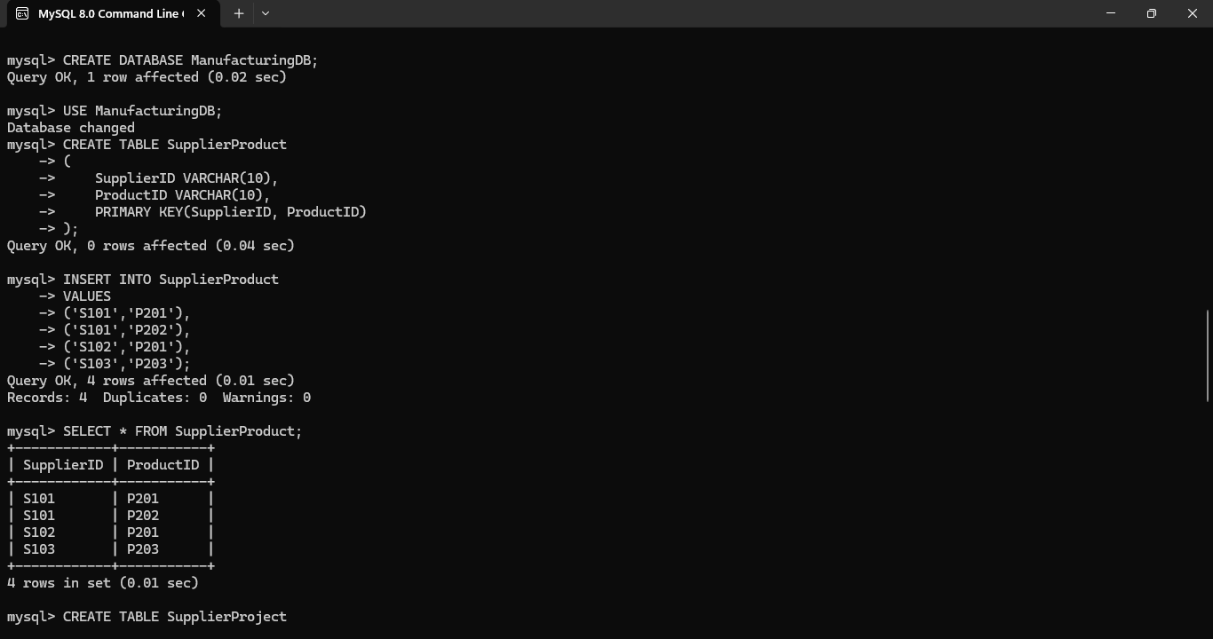

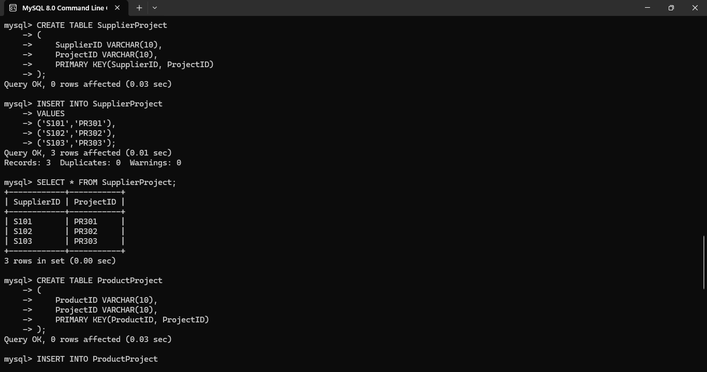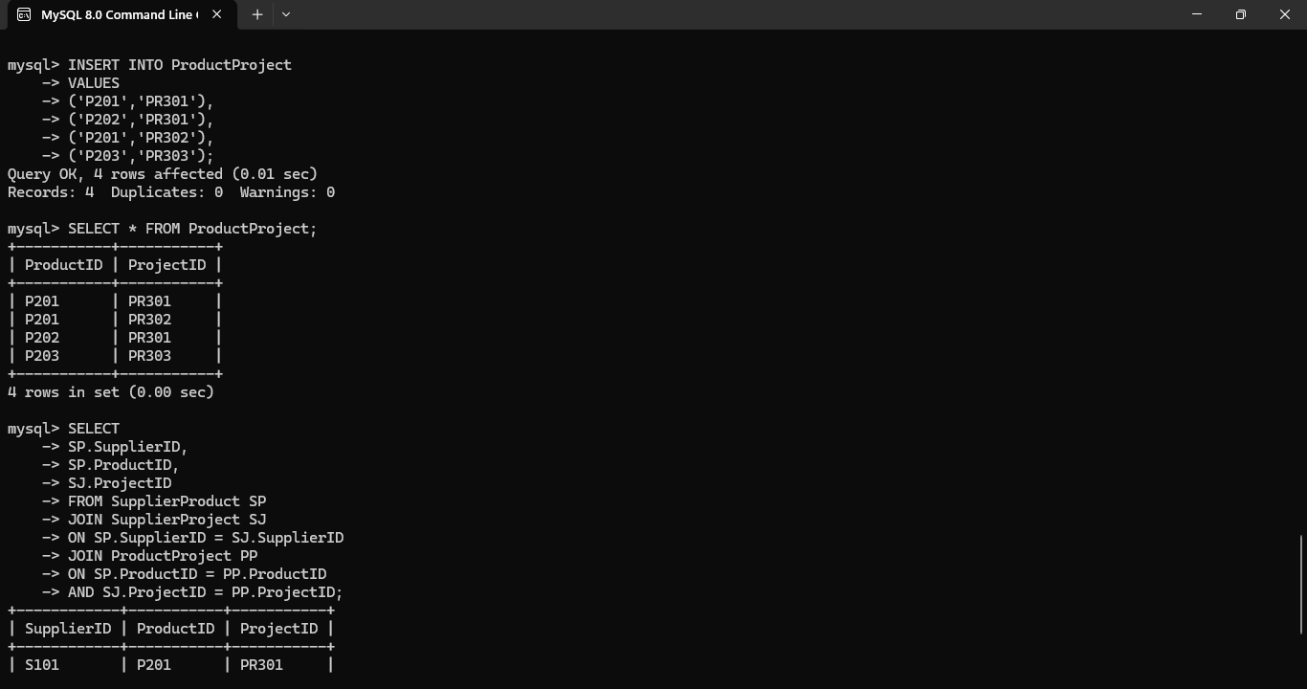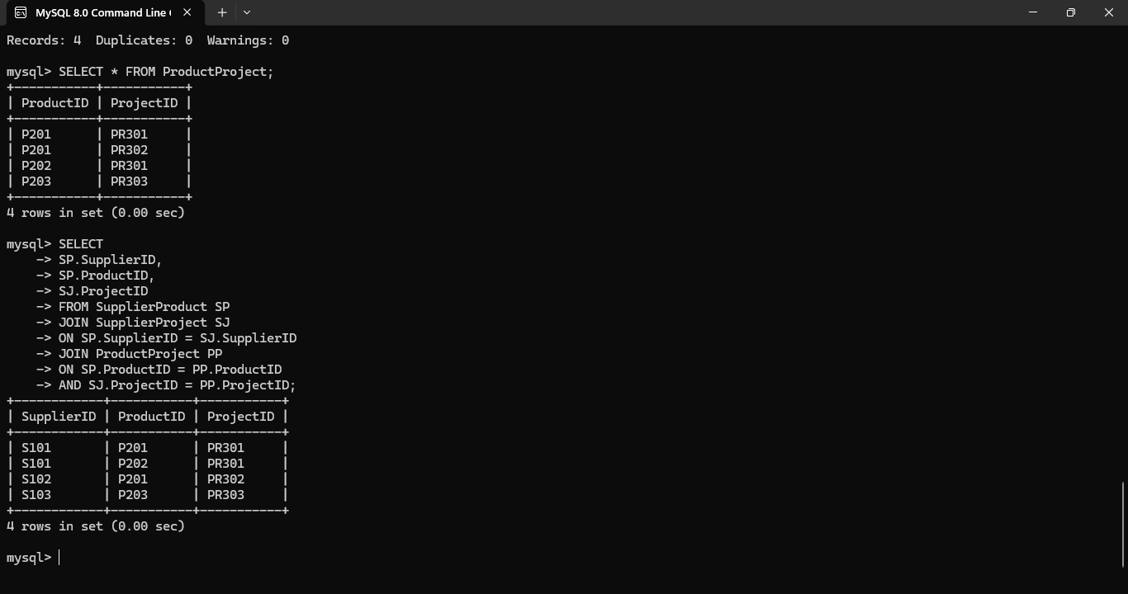
Reasoning
- The original table contains join dependencies, causing redundant data.
- The original relation can be reconstructed using joins without any loss of information.
- This decomposition satisfies Fifth Normal Form (5NF).

Conclusion
The manufacturing database was analyzed for join dependencies and successfully decomposed into Fifth Normal Form (5NF). The decomposition eliminates redundancy, preserves all information through lossless joins, and improves the overall consistency and maintainability of the database.

Q10. A system uses inefficient SQL queries for data retrieval. Analyze the queries and optimize them using joins, indexing concepts, or query restructuring.
Scenario-Based Explanation
An e-commerce company stores customer and order information in separate tables. The existing SQL queries use unnecessary subqueries, causing slower execution as the database grows. To improve performance, the queries are optimized by replacing subqueries with JOINs and creating indexes on frequently searched columns. This reduces query execution time and improves overall database efficiency.
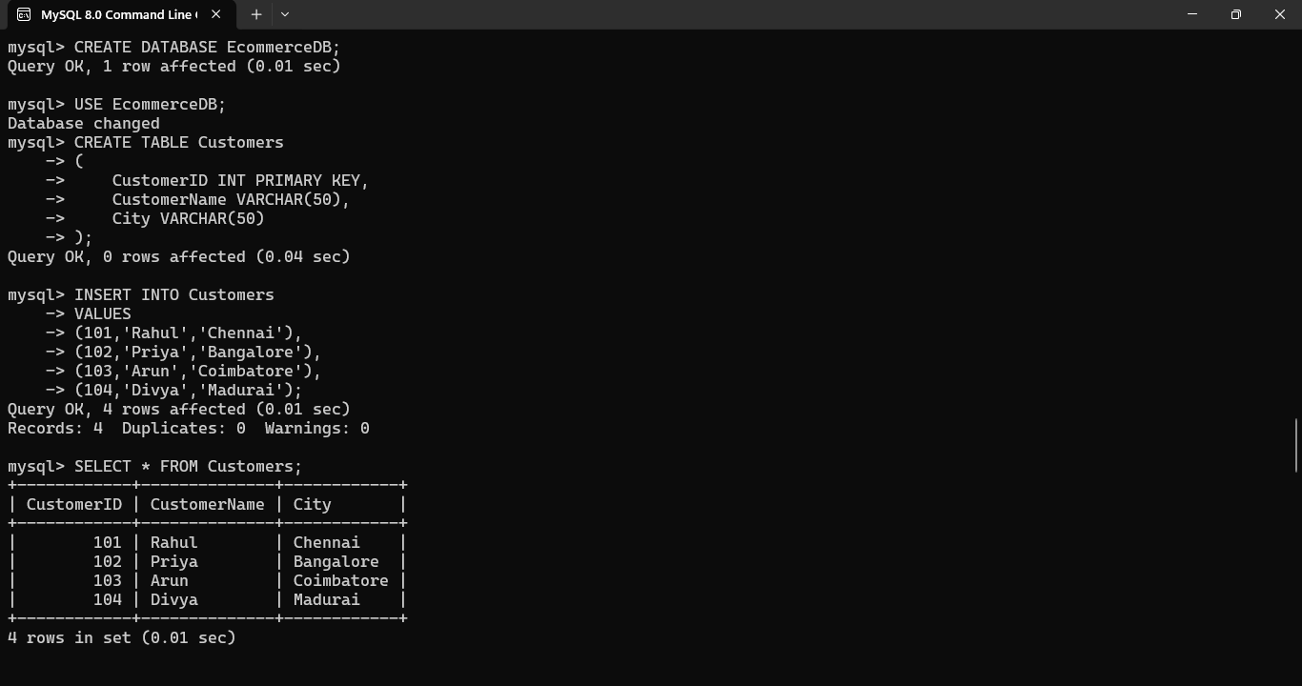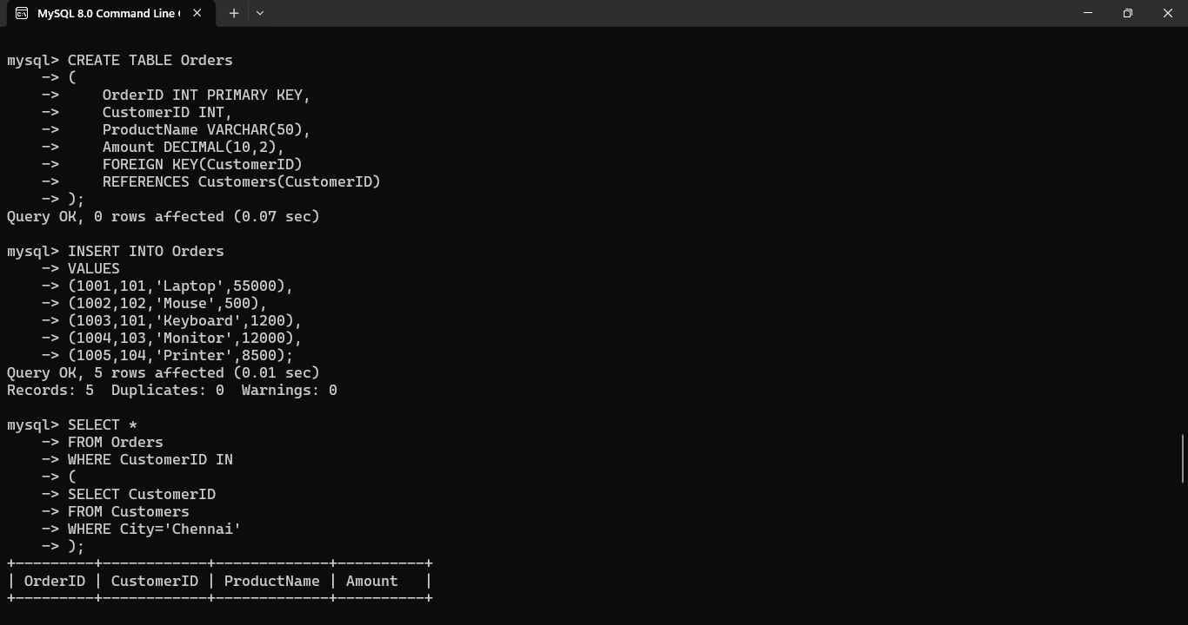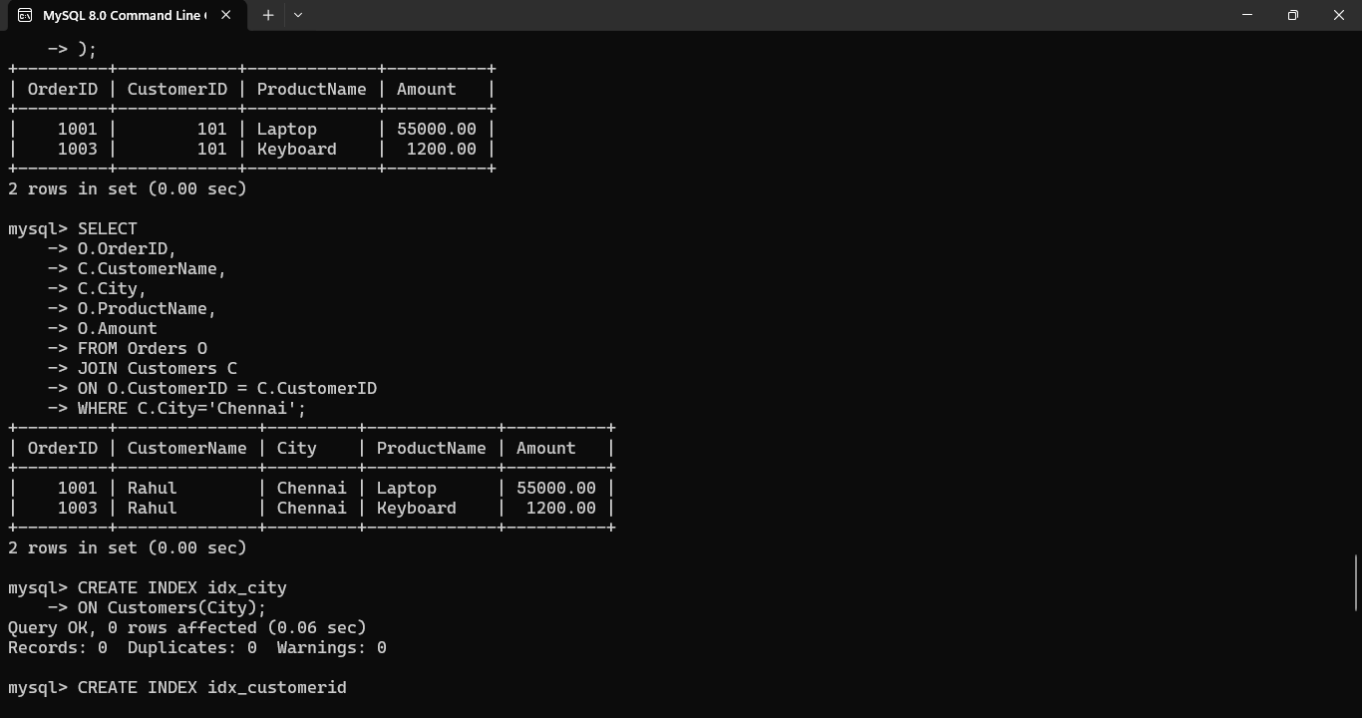

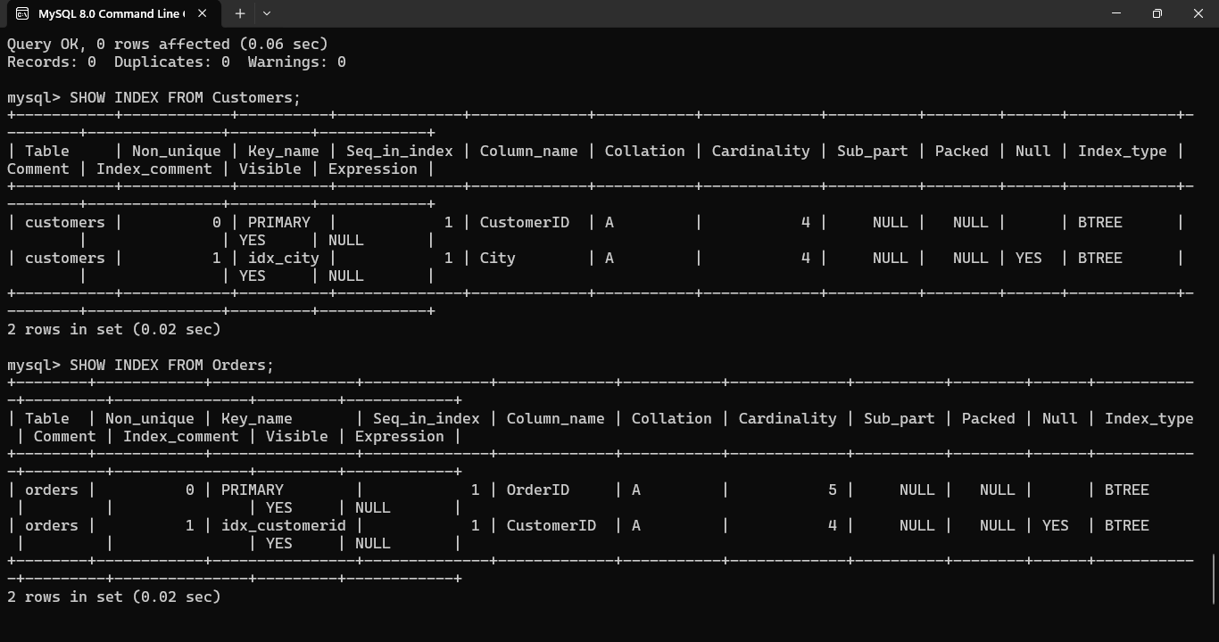

Justification
- The original query uses a subquery, which may become slower with large datasets.
- The optimized query uses a JOIN, which is generally more efficient for retrieving related data.
- Creating indexes on frequently searched columns (City and CustomerID) speeds up query execution.
- The optimized approach improves database performance and scalability.

Conclusion
The SQL query was successfully optimized by replacing the subquery with a JOIN and creating appropriate indexes. These optimizations reduce query execution time, improve data retrieval performance, and enhance the scalability of the e-commerce database.

